- COMPANY PROFILE

1.1 History Of The Organization
Softionik Solutions (OPC) Private Limited is a One-Person Company (OPC) established on 4 October 2023 in Mangaluru, Karnataka with CIN U62013KA2023OPC179362. The company evolved from a group of seasoned professionals in technology, HR, sales, and marketing, built upon over seven years of industry experience
1.1.1 Objectives
- To deliver quality IT services—training, consulting, planning, and managed services allowing businesses to devote attention to core functions.
- To invest in local communities by offering subsidized or free services to non-profit entities.

1.1.2 Operations Of The Organization

Softionik provides end-to-end software services: iOS & Android app development, web and Windows applications, cloud management, UX/UI design, IT management, data security, and comprehensive software testing. It employs qualified staff operating Monday–Saturday, 9 AM–8 PM, from its Balmatta location in Mangaluru.

  - Major Milestones
- Incorporated as OPC on 4 October 2023
- Achieved 5+ years of industry experience, transitioning into its latest OPC structure.
- Completed 120+ projects and served 50+ clients, showcasing rapid growth within a short span

  - Structure of the Organization
- Type: One-Person Company, non-government entity
- Founder & Managing Director: Sudheendra Kulal, DIN 10341242, appointed at inception .
- Team Size: 11–50 employees, including professionals in HR, technology, sales, and marketing

1.4 Services Offered
Softionik's key services include:
- Mobile App Development: iOS and Android (React Native, Flutter, native)
- Web & Windows App Development
- Cloud Management & Data Security
- UX/UI and IT Infrastructure Design
- IT Management and Consulting
- Comprehensive Testing Services

2. ABOUT THE DEPARTMENT
2.1 Specific Functionalities of the Department
During my work on the SportsLine project, I was part of the Web Application Development Department, which is responsible for designing, developing, and
maintaining scalable web solutions for e-commerce. This department plays a vital role in delivering robust, user-friendly web applications using modern JavaScript frameworks and libraries.
Key functionalities include:
- Designing responsive and intuitive user interfaces using React.js.
- Developing RESTful APIs and backend logic with Node.js and Express.js.
- Integrating frontend and backend for seamless data flow (e.g., product listings, cart, orders).
- Managing user authentication and authorization (login, registration, protected/admin routes).
- Implementing features for both customers (shopping, cart, wishlist, orders) and admins (inventory, analytics, bulk orders).
- Conducting unit and integration testing for both frontend and backend.
- Ensuring code quality, maintainability, and adherence to best practices.
- Deploying the application and maintaining production environments.

2.2 Roles and Responsibilities of Individuals
The department consists of the following roles:
- Project Manager: Oversees project planning, resource allocation, and ensures timely delivery of features.
- Frontend Developer (React.js): Designs and implements user interfaces, manages state, and handles client-side logic.
- Backend Developer (Node.js/Express): Develops REST APIs, manages database operations (MongoDB), and handles server-side logic.
- UI/UX Designer: Creates wireframes, mockups, and final UI designs to ensure a smooth user experience.
- Quality Assurance (QA) Engineer: Conducts manual and automated testing, prepares bug reports, and ensures the application meets quality standards.
- DevOps Engineer: Manages deployment pipelines, monitors application performance, and handles server maintenance.
My role primarily focused on:
- Implementing customer-facing modules (product catalog, cart, checkout, order tracking).
- Consuming backend APIs for product data, user authentication, and order management.
- Collaborating with backend developers and UI/UX designers for feature integration.
- Debugging and optimizing frontend performance and user experience.
- Writing unit tests for React components and utility functions.

2.3 Testing
Testing in the department is carried out through both manual and automated approaches:
- Manual Testing: Used for UI validation, functional testing of new features, and exploratory testing during development sprints.
- Automated Testing Tools: Used for regression testing, integration testing, and unit testing.
  - Example tools:
  - Postman for manual API endpoint validation.
3. INTERNSHIP EXPERIENCE
4.1 Skills Developed During the Training period
4.1.1 Introduction
During my internship, I undertook the role of a Full Stack Web Developer on a real-world project titled SportsLine, an e-commerce platform for sports merchandise and bulk jersey orders. This training period provided a dynamic environment to work on the complete web application lifecycle—from UI design to backend API development and deployment. The internship was structured to offer hands-on experience in both frontend and backend development, with a focus on practical, industry-relevant skills.The primary goal of the training was to gain technical exposure in full-stack web development, enhance problem-solving abilities, and improve collaboration and professional communication skills.
4.1.2 Skill Set Acquired
Technical Skills:
- React.js for building responsive and interactive user interfaces.
- Node.js and Express.js for backend API development.
- MongoDB for managing structured application data.
- REST API integration using Axios for seamless frontend-backend communication.
- Git for version control and collaborative development.
- Postman for testing and debugging backend APIs.

Soft Skills:
- Effective communication with designers and backend teams.
- Collaborative development through daily stand-ups and task tracking.
- Agile methodology and sprint planning.
- Time management through milestone-based tasks.

Domain-Specific Knowledge:
- Understanding e-commerce workflows (product catalog, cart, checkout, order management).
- User-centric design for both customer and admin modules.
- Security best practices for authentication and authorization.

4.2 Application of Skills to Tasks
4.2.1 Maior Tasks Assigned:
- Developed customer-facing UI screens: Home, Product Listing, Product Details, Cart, Checkout, and Order Tracking.
- Integrated user registration and login with JWT-based authentication.
- Consumed backend APIs for product data, cart management, and order processing.
- Assisted in designing REST API endpoints for product management and bulk order processing.
- Created reusable React components and followed clean coding standards.
- Implemented admin features for inventory management, analytics, and bulk order handling.
- Wrote unit and integration tests for critical modules.
4.2.2 Context and Importance:
The tasks I completed directly contributed to the company’s vision of building a comprehensive sports merchandise platform. The modules I worked on enabled end users to:
- Seamlessly browse and purchase sports products.
- Place and track bulk jersey orders for teams and organizations.
- Receive real-time updates on order status and inventory.
- Allow admins to efficiently manage products, orders, and customer data.
This streamlined user experience aligns with the objective of delivering a high-impact, scalable e-commerce solution tailored to the sports industry.

4.3 Project Details
4.3.1 Software Requirements Specification (SRS):
Functional Requirements:
- User registration and login with secure authentication.
- Product browsing, search, and cart functionality.
- Bulk order system for team jersey purchases.
- Admin panel for product, order, and customer management.
- Real-time notifications for order status and inventory updates.
Non-Functional Requirements:
- The web app must be responsive and accessible on all major browsers and devices.
- Data should be stored securely in MongoDB.
- API response time should be under 1 second for optimal user experience.
- Notifications should be delivered in real time.
Constraints:
- The platform must support at least 1,000 concurrent users.
- Network connectivity may vary; basic offline handling for cart data is essential.
- Admin panel access should be restricted via secure login and role-based permissions.

4.3.2 Existing System
Currently, there is no dedicated website for the shop to manage or sell sports merchandise, bulk jersey orders, or customer interactions. All operations, including product sales, order management, and inventory tracking, are handled manually—often through phone calls, in-person visits, or basic record-keeping methods such as spreadsheets or paper logs.In the broader market, existing e-commerce platforms for sports merchandise typically focus on either individual product sales or bulk team orders, but rarely both in a unified system. These platforms often lack robust admin management tools, resulting in manual tracking of inventory and orders, which leads to operational inefficiencies. Additionally, customer experience is often fragmented, with limited real-time updates and poor integration between customer and admin modules. The absence of a dedicated online platform for the shop results in:
- Missed opportunities for online sales and customer engagement.
- Increased risk of errors in order and inventory management.
- Inefficient communication between customers and shop staff.
- Limited ability to scale operations or offer modern conveniences such as real-time order tracking and notifications.
4.3.3 Proposed System
The proposed system, SportsLine, is a comprehensive web application developed using React.js for the frontend and Node.js/Express.js for the backend. It integrates two primary modules: Customer and Admin.
- Customer Module:
Customers can browse and purchase sports products, add items to their cart, and place both individual and bulk orders (e.g., for team jerseys). Users receive real-time updates on order status and inventory changes.
- Admin Module:
Admins can manage products by adding, updating, or removing items, process customer and bulk orders, and update their status. The admin panel also provides analytics and inventory management tools, streamlining business operations.This integrated system reduces operational overhead, enhances customer experience through timely notifications and personalized suggestions, and streamlines admin tasks by consolidating product, order, and customer management into a single platform.

4.3.4 Design:
System Architecture:
Architecture Type: Client–Server Model

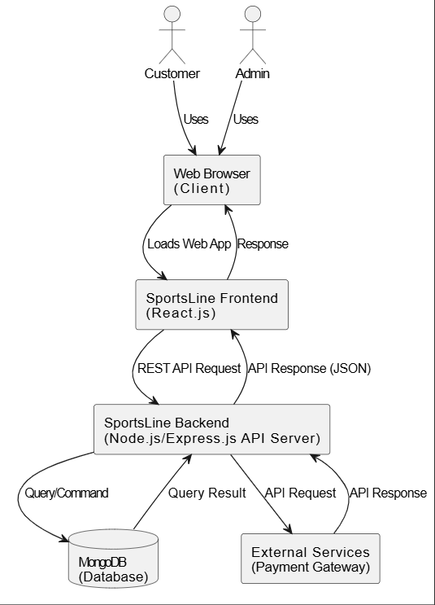

4.3.7 USE CASE Diagram
A use case diagram is a graphic depiction of the interactions among the elements of a system. It is a methodology used in system analysis to identify, clarify and organize system requirements. A use case diagram does not show the detail of the use case, it only summarizes some of the relationships between use case and the actors. Use case diagrams are usually referred to as behavior diagrams, which is used to describe set of actions that systems should or can perform in collaboration with one or more external users of the system i.e. Actors. Each use case should provide one or more observable and valuable result to the actor.

SL.NO | DIAGRAM | DESCRIPTION
1 |  | Use case: Horizontally shaped ovals  that represent the different uses that a user might have.
2 |  | Actors: Stick figures that represent  the people actually employing the use cases.
3 |  | Associations: A line between actors and use cases. In complex diagrams, it is important to know which actors are  associated with which use cases.
4 |  | System boundary boxes: A box that sets a system scope to use cases. All use cases outside the scope of that  system.

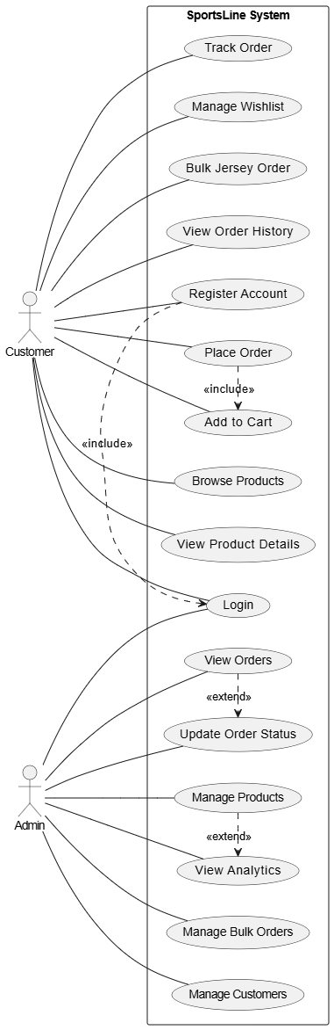
Fig .1 (Use case)

4.3.8 Class Diagram
The Class Diagram provides a high-level blueprint of the core entities in the Ayush mobile application and how they interact with each other. It follows an object-oriented design approach and showcases the relationships between different classes used in the system.
- Class Name:
  - The name of the class is typically written in the top compartment of the class box and is centred and bold.
- Attributes:
  - Attributes, also known as properties or fields, represent the data members of the class. They are listed in the second compartment of the class box and often include the visibility (e.g., public, private) and the data type of each attribute.
- Methods:
  - Methods, also known as functions or operations, represent the behaviour or functionality of the class. They are listed in the third compartment of the class box and include the visibility (e.g., public, private), return type, and parameters of each method.
- Visibility Notation:
  - Visibility notations indicate the access level of attributes and methods. Common visibility notations include:
    - + for public (visible to all classes)
    - - for private (visible only within the class)
    - # for protected (visible to subclasses)

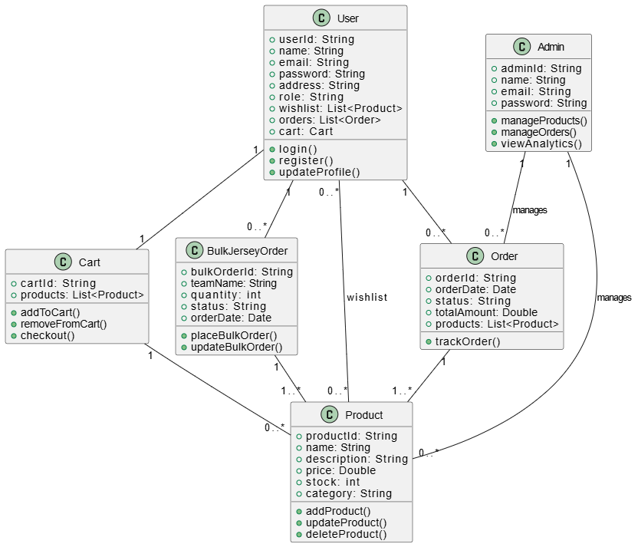 Fig .2 (Class Diagram)

4.3.9 Sequence Diagram
A Sequence Diagram is a type of UML (Unified Modeling Language) diagram used to show how objects or components in a system interact with each other over time. It focuses on the order of messages exchanged between different parts of the system to perform a specific function, making it useful for visualizing the flow of control in a use case. The diagram is read from top to bottom, where time flows vertically.
Following are the main components and its symbols in sequence Diagrams:

SL.NO | DIAGRAM | DESCRIPTION
1 |  | Object symbol: Represents a class or object in UML. The object symbol demonstrates how an object will behave  in the context of the system.
2 |  | Synchronous message symbol: Represented by a solid line with a solid arrowhead. This symbol is used when a sender must wait for a response to a  message before it continues.
3 |  | Asynchronous message symbol: Represented by a solid line with a lined arrowhead. Asynchronous messages don't require a response before the  sender continues.

USER:
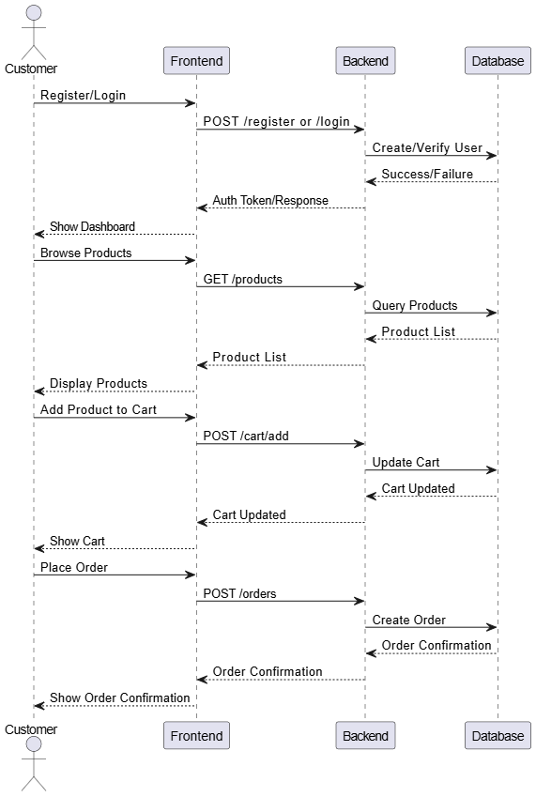
Fig .1 (Sequence Diagram)

ADMIN:
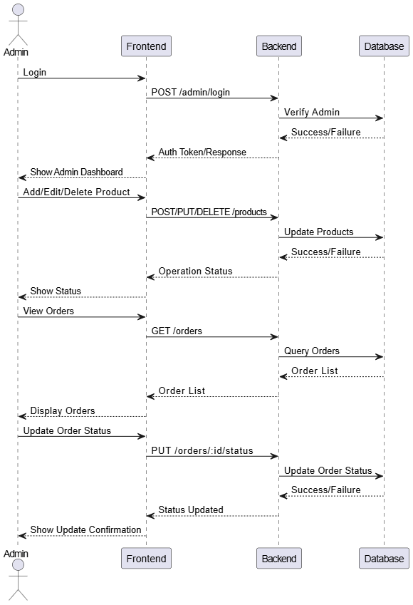
Fig .1 (Sequence Diagram)

ACTIVITY DIAGRAMS

An activity diagram is a behavioural diagram, i.e., it depicts the behaviour of a system. An activity diagram portrays the control flow from a start point to a finish point, showing the various decision paths that exist while the activity is being executed. An activity diagram is basically a flowchart to represent the flow from one activity to another. The activity can be described as an operation of the system.
Following are the main components and their symbols in activity Diagrams:
SL.NO | DIAGRAM | DESCRIPTION
1 |  | Activity or action state: An action state represents the action of objects.
2 |  | Decision symbol: A diamond represents a decision symbol with alternative paths
3 |  | Action flow: Action flow also called as path, it shows the transitions from one action state to another.
4 |  | Start point: A small filled circle followed by an arrow represents initial state or start state.

